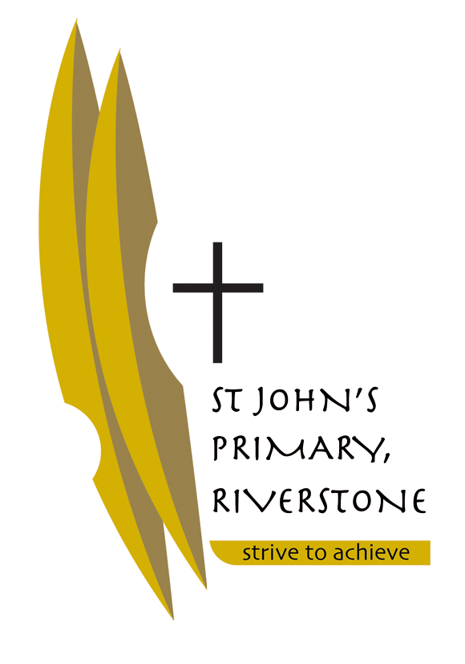
5 McCulloch Street
Riverstone NSW 2765
02 9627 2588
riverstone@parra.catholic.edu.au

Tuesday 12th December 2017

Dear Parents of Stage Two,

We are looking forward to teaching your child in 2018 and working in partnership with you to bring about the best learning for your child.
Below we have listed some resources that we request you purchase before the school year starts so that the transition into the school year will be smooth. Most of the resources will be provided by the school. Please check at the end of each term if your child requires more stationery e.g. glue sticks, pencils etc.

Please ensure that all of your child’s belongings are labelled clearly so that they can easily identify them, including their school bag/school clothing /jackets /jumpers /lunchbox/ drink bottle etc.

Wishing you all a happy, safe and holy Christmas.

Kind Regards,

Mr Liam Shields and Ms Amanda Jeffery

RESOURCES REQUIRED FOR 2018 – STAGE TWO

- Tissue box x 2
- Box of coloured pencils – pack of 24
- Large UHU glue sticks – 4 ( keep spares at home)
- Lead pencils 2B – 6
- 30cm plastic/wooden ruler – 1
- Pencil sharpener with barrel
- Highlighters
- Pencil Case
- Paint Shirt
- Headphones labelled not wireless (individual)

