Snack Shack Price List - Term 1 2018
Snack Shack will be open Monday & Friday!
Red Rock Deli Chips………..……………………..$1.00 (A)
Honey Soy / Sea Salt
Salt’n’Vinegar Chips………………………………..$1.00 (A)
Jumpy’s – Chicken Flavour…………………….$1.00 (A)
JJ’s – Chicken Flavour…………………………..$1.00 (A)
Mamee Noodle- BBQ Flavour………………$0.60 (A)
Plain Popcorn……………………………………………$0.60 (A)
Mini Choc Chip Cookies…………………………$0.80 (A)
Mini Yoghurt Bars - Strawberry………..$0.20 (A)
Freezer Items Drinks
Frozen yoghurt- SpringWater 600ml (G)……$1.00
chocolate/vanilla…….….$1.70(A) Just Juice Poppers(G)……….$1.00
Frozen yoghurt- (Apple/apple & Blackcurrant/orange)
strawberry/vanilla……..$1.70(A) Just Juice Snack Cup (G).…$0.60
Bulla Ice Cream Cup- (Apple/ apple & blackcurrant)
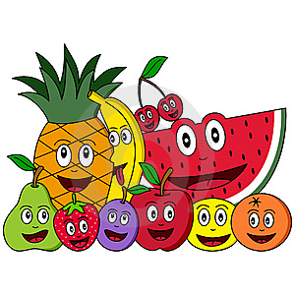
Vanilla…………………………...$1.00(A)
Icy Pole- Lemonade…….$0.80(G)
Paddle Pop…………………….$1.20 (A)
(assorted flavours depending on availability)
Quelch Sticks……………………..$0.50 (G)
(assorted flavours)
Please Note: Not all items are available all the time due to availability from supplier
(A) Eat in moderation (G) Eat as often as you like

