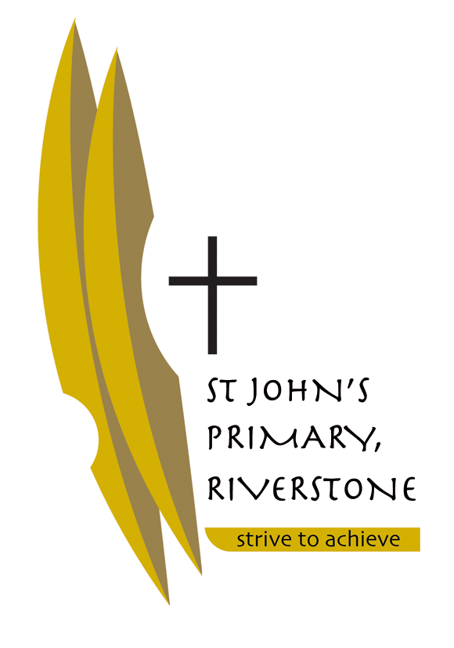

5 McCulloch Street

Riverstone NSW 2765

02 9627 2588

riverstone@parra.catholic.edu.au

Tuesday 12th December 2017

Dear Parents of Stage Three,

I am looking forward to teaching your child in 2018 and working in partnership with each family. Below I have listed some resources that I request you purchase before the school year starts so that the transition into the school year will be smooth. (Most of the resources will be provided by the school.) Please check at the end of each term if your child requires more stationery e.g. glue sticks, pencils etc.

**Please ensure that all of your child’s belongings are labelled clearly** so that they can easily identify them, including their school bag/school clothing /jackets /jumpers /lunchbox/ drink bottle etc.

We wish you all a happy, safe and holy Christmas.

Kind Regards,

C:\Users\myouell\AppData\Local\Microsoft\Windows\Temporary Internet Files\Content.IE5\TYP0HSNE\MC900411085[1].wmf

Mrs Kim Roffmann

RESOURCES REQUIRED FOR 2018 – STAGE THREE

* Box of coloured pencils & textas – pack of 24
* Assorted coloured highlighters x 4
* Blue Pens x 4
* Black Pens x 4
* Red Pens x 2
* Large UHU glue sticks x 4 (per term)
* Lead pencils HB x 6
* Geometry Set
* Pencil Case
* Paint Shirt / Smock
* 30cm Wooden Ruler
* 2 x 96 page Exercise Books (for Homework)
* 1 x Refillable Display Book
* Scissors
* Erasers
* Clear Contact
* Tissues
* Baby Wipes
* Headphones labelled not wireless (individual)