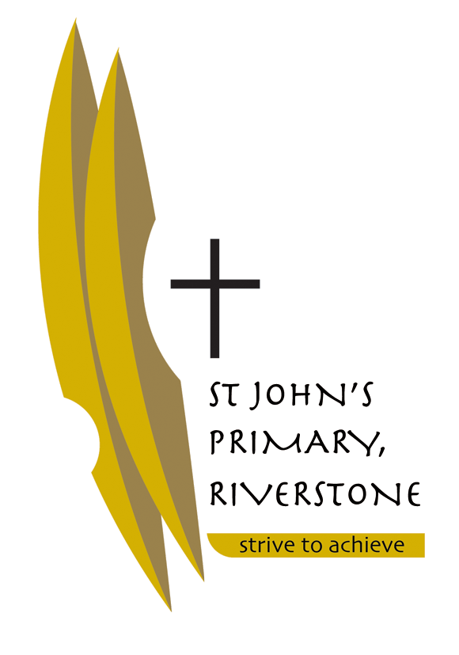
5 McCulloch Street
Riverstone NSW 2765
02 9627 2588
riverstone@parra.catholic.edu.au

Tuesday 12th December, 2017

Dear Parents of Stage One,

We are both looking forward to teaching your child in 2018 and working in partnership with each family.

Below we have listed some resources that we request you purchase before the school year starts so that the transition into the school year will be smooth. Most of the resources will be provided by the school, however if your child would like to bring along their own pencil case this will be allowed.

NO GLITTER PENS, TEXTAS OR PENS OF ANY SORT WILL BE PERMITTED.

Please ensure that all of your child’s belongings are labelled clearly so that they can easily identify them, including their school bag/school clothing /jackets /jumpers /lunchbox/ drink bottle etc.

We wish you all a happy, safe and holy Christmas.

Kind Regards,

Miss Amee Paes and Mrs Carol Spillane (Term 1 Temporary position)

RESOURCES REQUIRED FOR 2018 – STAGE ONE

- Paint Shirt
- Box of coloured pencils – pack of 24 or twistable crayons
- Large UHU glue sticks – 6
- Lead pencils 2B – 6
- Pencil Case (optional)
- Slimpick Document Folder x 1– used as their reading folder
- Headphones labelled not wireless (individual)
- Tissues x 2 boxes
- Baby wipes x 2
- Paper towels x 2 rolls

