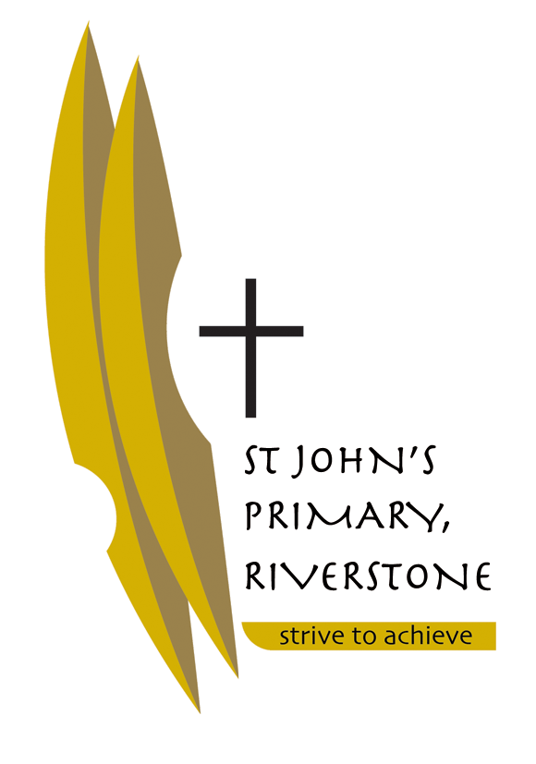
5 McCulloch Street
Riverstone NSW 2765
02 9627 2588
riverstone@parra.catholic.edu.au

Tuesday 12th December 2017
Dear Parents of Early Stage One,

I look forward to teaching your child in 2018 and working in partnership with each family.
Below I have listed some resources that we request you purchase before the school year starts so that the transition into the school year will be smooth. Most of the resources will be provided by the school.

Please ensure that all of your child’s belongings are labelled clearly so that they can easily identify them, including their school bag/school clothing /jackets /jumpers /lunchbox/ drink bottle etc.

School will resume for 2018 on Wednesday 31st January and I look forward to seeing you all then.

Wishing you all a happy, safe and holy Christmas.

Kind Regards,

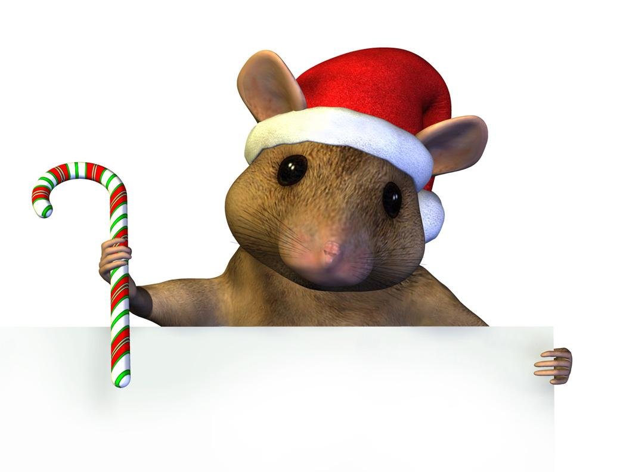

Miss Charlene Saliba

RESOURCES REQUIRED FOR 2018 – EARLY STAGE ONE

- Tissue box x 1
- Paper Towel x 1
- Box of Colour Pencils – Pack of 24 or twistable crayons
- Textas - Pack of 12
- Lead Pencils – 2B x 2
- UHU Glue Sticks – 6
- Pencil Case
- Paint Shirt
- Pencil Case
- Slimpick Document Folder x 1– used as their reading folder
- Baby wipes x 2 packets
- Headphones labelled not wireless (individual)

